University Of Engineering and Technology, Lahore Computer Engineering Department

Course Name: PF | Course Code: CMPE-112L
Assignment Type: LAB | Dated:
Semester: 1st | Session: 2026 spring
Lab/Project/Assignment #: 11 | CLOs to be covered: CLO4
Lab Title: Exceptional Handling | Teacher Name: Hafiz Muhammad Mubashar

Lab Evaluation:

CLO1 | Apply appropriate programming techniques to create executable programs to solve well defined problems
 | Level1 | Level2 | Level3 | Level4 | Level5 | Level6
(5)
Total |  |  |  |  |  | /5

Rubrics for Current Lab Evaluation

Scale | Marks | Level | Rubric
Excellent | 5 | L1 | Submitted all lab tasks, BONUS task, have good understanding.
Very Good | 4 | L2 | Submitted the lab tasks but have good understanding
Good | 3 | L3 | Submitted the lab tasks but have weak understanding.
Basic | 2 | L4 | Submitted the lab tasks but have no understanding.
Barely Acceptable | 1 | L5 | Submitted only one lab task.
Not Acceptable | 0 | L6 | Did not attempt

LAB No 11

Lab Goals/Objectives:
- To understand exceptions and errors in Python.
- To learn how to handle runtime errors.
- To use try, except, else, and finally blocks.
- To improve program reliability.

Equipment Required:
- Computer/Laptop
- Python
- Visual Studio Code / PyCharm / IDLE
- Window operating system

Theory:
Exception handling is a technique used to prevent a program from crashing when an error occurs during execution. Python provides the try and except blocks to detect and handle errors gracefully. The else block executes when no exception occurs, while the finally block alway executes regardless of whether an exception is raised. Exception handling improves the reliability and user-friendliness of a program.

Lab Work:

Task 1:
Write a Python program using try-except to take an integer age input and display an error message if the user enters letters instead of a number.
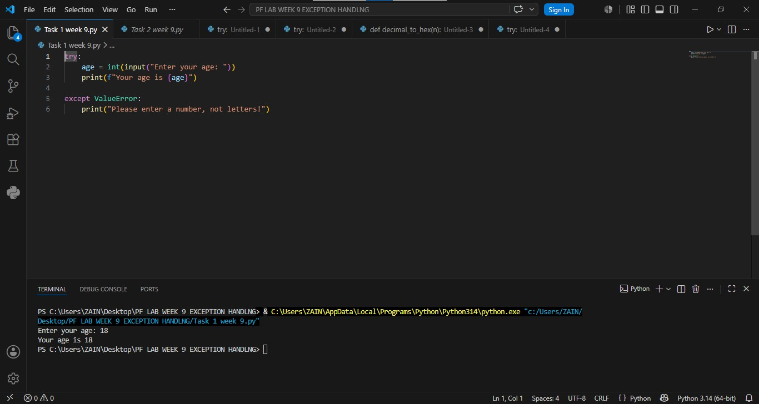
Result:

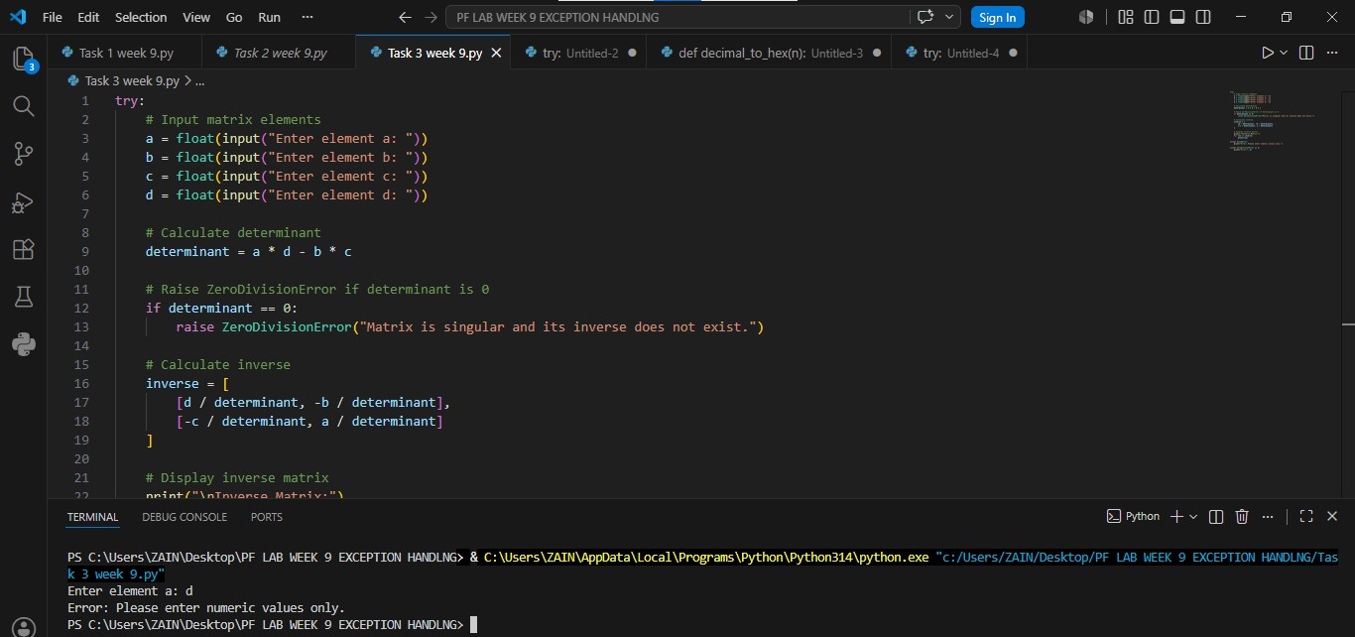
Task 2:
Write a Python program using try-except to take age as an integer input from the user and handle ValueError if the input is not a number.

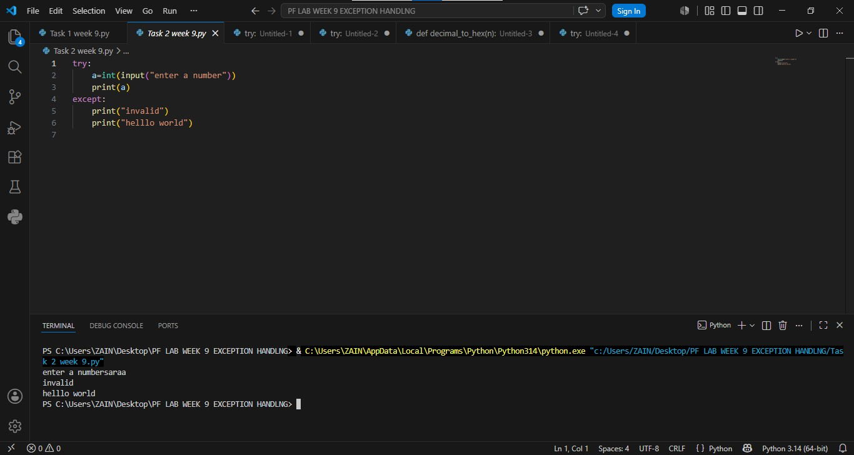
Result:

Task 3:
Write a Python program to take four float inputs for a 2x2 matrix, calculate its determinant and inverse, and handle ValueError for non-numeric input and ZeroDivisionError if the determinant is zero.
Result:

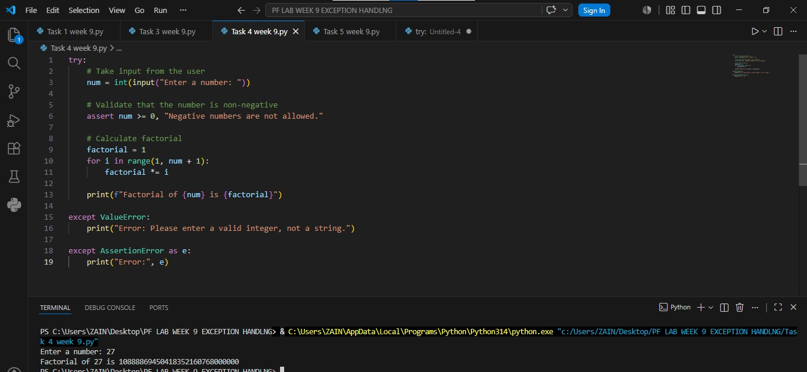
Task 4:
Write a Python program with a function that converts a decimal number to hexadecimal, raises a TypeError if the input is a string, and handles the exception to display an error message.

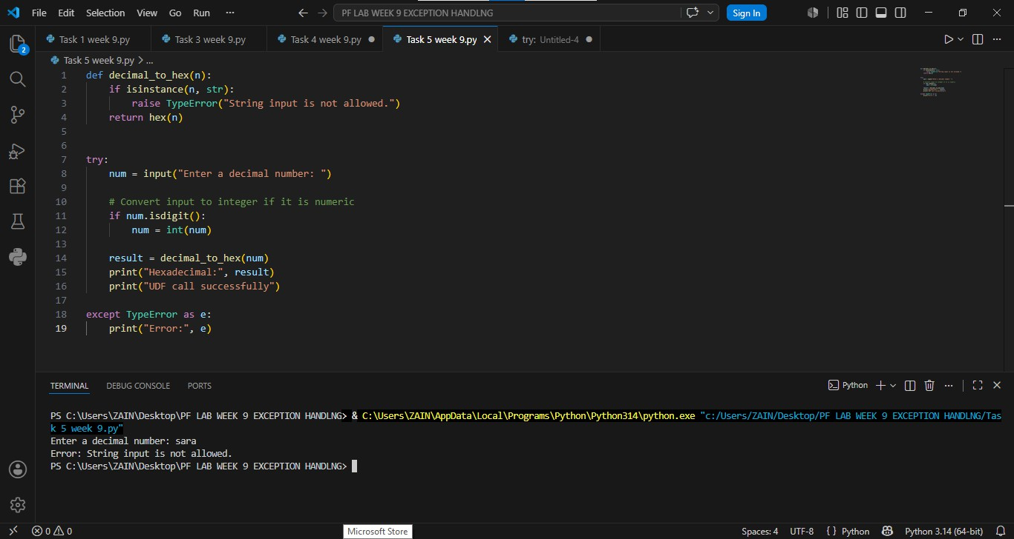
Result:

Task 5:
Write a Python program to take an integer input, use assert to ensure the number is non-negative, calculate its factorial, and handle ValueError for invalid input and AssertionError for negative numbers.

Result:

Task 6:

Write a Python program to take name, address, contact number, age, and gender as input, validate each field with specific conditions using exceptions, and display the biodata only if all inputs are valid.

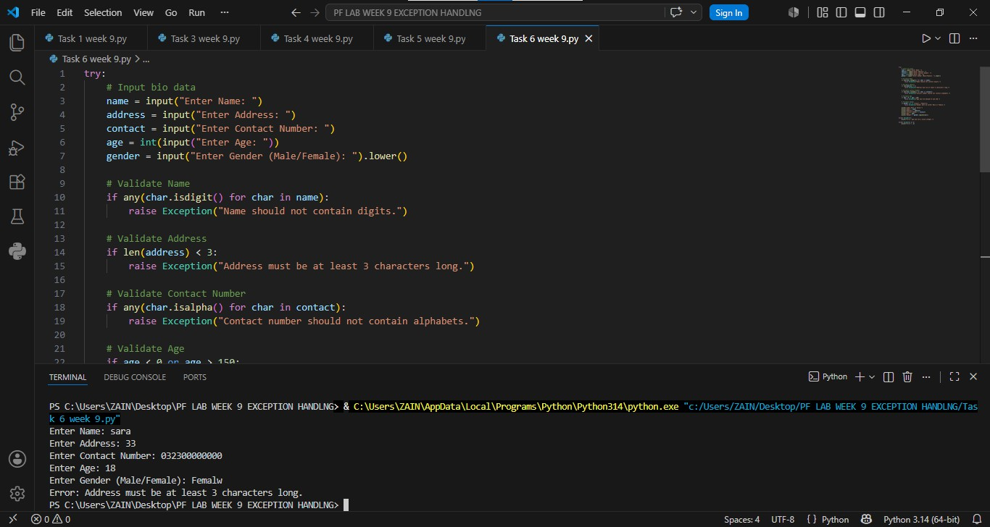
Result:

Conclusion:
This lab helped us understand the importance of exception handling in Python programs. We learned how to use try, except blocks to detect and handle runtime errors effectively. By using these techniques, programs become more reliable, user-friendly, and less likely to terminate unexpectedly due to errors

